Dental chemistry First course
First course Lec. 5

Colloids and colloidal dispersion
Solutions: are homogenous mixtures of solvent and solute molecules. The maximum diameter of the solute particles in a true solution is about 1nm.

Types of solutions
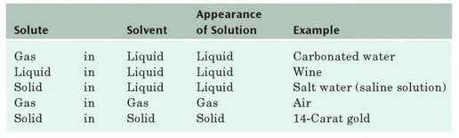

Solubility: the amount of solute that dissolves in a given quantity of solvent to form a saturated solution.

Factors affecting solubility:
- Kind of solute (as discussed earlier in solubility rules)
- Kind of solvent (as discussed earlier in CRC hand book) 3- The temperature.
Increasing temperature increases the solubility of the most salts, while, decreasing the temperature increases the gas solubility.
Example: When water is boiled, the bubbles that form during water heating are air escaping from water because the dissolved air is less soluble in water at elevated temp.

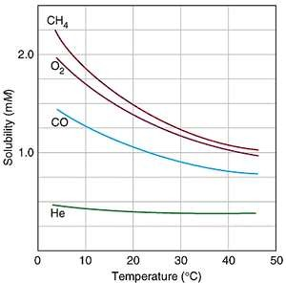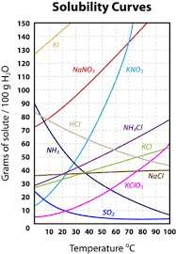

4- The pressure above the solvent.
According to Henry's law, the gas solubility is proportional to partial pressure of the gas above the solution. It is expressed mathematically as:

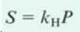

Where S is gas solubility (expressed as mass of solute per unit volume of solvent), K_{H} is the constant of Henry's law for the gas for a particular liquid at a given temperature and p is the partial pressure of the gas.

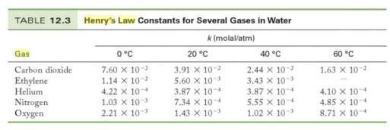

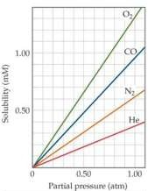

Example: The carbonated beverages contain the carbon dioxide (CO₂) gas dissolved in water and are bottled under high pressure. When bottled is opened, the partial pressure of CO₂ above the liquid decreases and CO₂ solubility decreases.
Colloidal dispersion: In colloidal system, the diameter of the solute particles ranges from 1 to 1000nm. Intermolecular attraction between molecules causes several hundred to several thousand of them to cluster together.
Three forces operate on the fine particles in solution:
- A gravitational force, tending to settle depending on their density relative to the solvent.
- A viscous drag force, which arises as a resistance to motion.
- The natural kinetic energy of particles and molecules which causes brownian motion.
If we consider the first two forces, we can easily calculate the terminal or limiting velocity, V, (for settling or rising), depending on the particles density relative to water) of a spherical particle of radius r.
F_{gravity} , the gravitational force, ղ is the viscosity
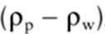 is the density difference between particle and
water.

Hence, if we assume a particle-water density difference of +1 g/cm³, we obtain the result:

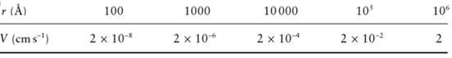

Clearly from 1 and 2 , small particles will take a very long time to settle and so a fine dispersion will be stable almost indefinitely, even for materials denser than water, but what about of factor 3? Each particle, independent of size, will have a kinetic energy, on average of around 1 KT. So the typical, random speed (v) of a particle (in any direction) will be roughly given by:
Again, if we assume that:
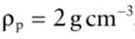
Then we obtain the results:

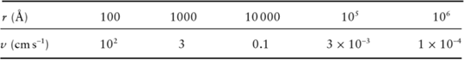

These values suggest that kinetic random motion will dominate the behavior of small particles, which will not settle and the dispersion will be completely stable. However, this point is really the beginning of "colloid science". Since these small particles have this kinetic energy they will, of course, collide with other particles in the dispersion. If there are attractive forces between the particles, each collosion might cause the growth of large aggregates, There is, in fact, a ubiquitous force in nature, called the van der Waals force, which is one of the
main forces acting between molecules and is responsible for holding together. The question here is why these clusters of molecule continue increase in the size until they settle out? The reason is that the particles all have the same electrical charge, these charges can be caused by adsorption of ions to the surface of particles as a result these charged particles repel each other and cannot form particles large enough to settle out.
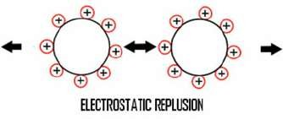

Type of colloids
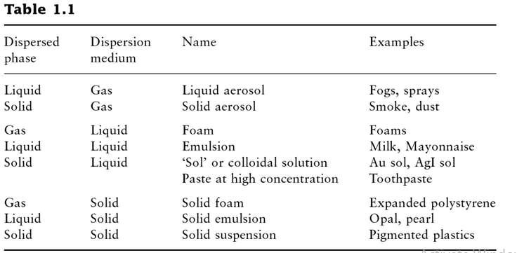
Dialysis and colloid :
Semipermeable membranes that selectively allow solvent to pass but retain dissolved solutes during osmosis. Cell membranes must be able to do more than this, because cells need to take in nutrients and discharge waste products. So dialyzing membranes are semipermeable membranes with larger pores than osmotic membrane that allow solvent, small molecules and ions to pass while holding back large molecules and colloidal particles. To understand this idea, see the following figure:
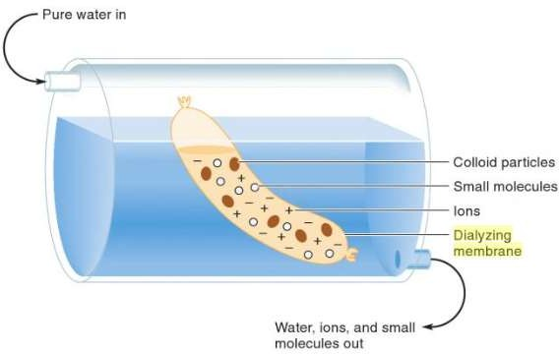
Inside a bag made from dialyzing membrane such as animal bladder. a mixture containing water, ions, small molecules and colloidal particles is placed in the bag. Water move in both directions of the membrane, it carries away ions and small molecules (but not large molecules) through the membrane.

Artificial kidney:
Dialysis of blood patients with renal failure helps to remove small solutes such as urea, creatinine and other toxins from the blood. The blood is pumped through tubing made of a dialyzing membrane such as cellophane. The membrane is porous enough to allow the constituents of the plasma, except plasma proteins, to diffuse in both directions. If the concentration of a substance is greater in the plasma than in the dialyzing fluid (Dialysate), there will be a net transfer of the substance from the plasma into the dialyzing fluid. The dialysis solution has levels of minerals that are similar to their natural concentration in healthy blood.
When kidney function is normal, creatinine is filtered from the blood through the kidneys. When creatinine levels are high, it can be an indicator of kidney disease.
Dialysate is the fluid that is used in dialysis to adjust the extracellular fluid composition and to maintain body homeostasis.

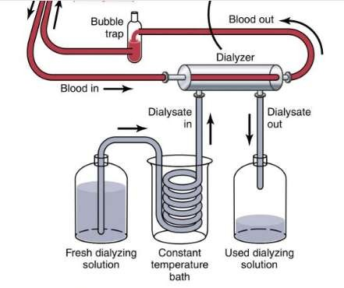 Artifcial kidney

Hydrocolloids:
Hydrocolloids is commonly used to describe a range of polysaccharides and proteins that are widely used in industrial sectors to perform a number of functions including thickening and gelling aqueous solutions, stabilizing foams, emulsions and dispersions.

Hydrocolloids in dentistry,
Hydrocolloid is a water-based colloid used as an elastic impression material. They are two types, reversible and irreversible hydrocolloids.
Reversible hydrocolloid is an agar impression material that can be heated to change a gel into a fluid sol state that can flow around the teeth and then cooled to gel again to make an impression of shapes of the oral structures.
Irreversible hydrocolloid is an alginate impression material that is mixed to convert to a gel by a chemical reaction which cannot changes to the origin. Alginate is the salt of deprotonated alginic acid.

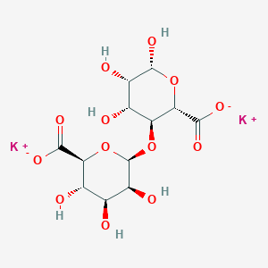 Potassium alignate

Agar is a powder derived from seaweed

Alginic acid is a polysaccharide compound present in the brown algae, it forms a viscous gum when hydrated,
Chemical composition of alginate powder used in impression:

Potassium alginate | 15-20%
Calcium sulfate dihydrate | 14-20%
Trisodium phosphate | 1%
Diatomaceoues earth | 55%
Other additive: | very small quantites
*Organic glycols
*Coloring agents
*Flavoring agents
*Disinfectants

The reaction between soluble potassium alginate and calcium sulfate produces insoluble calcium alginate. Structurally, calcium ions replace the potassium ions of two adjacent molecules to produce a cross-linked complex or polymer network. If this reaction allowed to undergo in an unaltered way, it does not allow sufficient working time This reaction is retarded in the presence of trisodium phosphate which react first with calcium sulfate to give calcium phosphate and then, when trisodium phosphate is consumed and exhauted from the medium of reaction, the insoluble calcium alginate been formed, so trisodium phosphate is added to slow down the reaction time and control the setting time.
Diatomaceous earth is finely ground silicate, it is act as filler which increase the strength and stiffness of the mix.
Organic glycol used as dustless to keep powder from becoming air bone when it is dispensed.
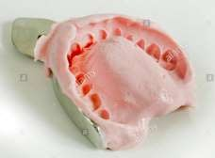

Dental Alginate Impression

Dimensional stability:
Alginate is very sensitive to moisture loss and will shrink as a result. Once the impression is removed from the mouth, it should be rinsed and disinfected, wrapped in a damp paper towel and sealed in zippered plastic bag.

Gel strength
- Manipulation of alginate material will affect the amount of water added, if too much or too little water used in mixing, the gel will be weakened.
- when an insufficient time is used for mixing, the strength of the final gell will be reduced.
- When there is insufficient spatulation (under mixing), the ingredients do not dissolve enough to permit the chemical reactions to complete. Also, over mixing produce poor results because any calcium alginate gel formed may be broken up.

The link between colloids and surfaces
The link between colloids and surfaces follows naturally from the fact that particulate matter has a high surface area to mass ratio. The surface area of a 1 cm diameter sphere (4πr²) is 3.14cm², whereas the surface area of the same amount of material but in the form of 0.1 µm diameter spheres is 314000cm². The enormous difference in surface area is one of the reasons why the properties of the surface become very important for colloidal solutions. The potential adsorption capacity of gel depends on the specific surface area. The increase in surface area gives rise to a corresponding increase in surface energy and surface reactions. Due to high surface area, more accurate impression and less susceptible to water loss or gain and therefore unwanted dimensional change.

References
- Carol D., Stephan E., William F., Dental Materials - E-Book: Clinical Applications for Dental Assistants, 2nd ed., Elsevier, 2011.
- Phillipis G., Williams P., Handbook of Hydrocolloids, 2nd ed., CRC, 2009.
- Pauline C., Alice E., The Dental Assistant, 7th ed., 2001
- Ronald L., Jack F., John M., Craig's Restorative Dental Materials - E-Book, 13th ed., Elsevier, 2012
- Richard P. Marilyn K., Applied Colloid and Surface Chemistry, Wiley, 2004
- Frank B., Suspensions of Colloidal Particles and Aggregates, springer, 2016.
- Spencer S, Michael S., Chemistry for Today: General, Organic, and Biochemistry, 6th ed., 2008.
- George H., The chemical basis of life, 2010
- Mario V., Tony R., Kurpad A., Guyton & Hall Textbook of Medical Physiology - E-Book: A South Asian Edition, Elsevier, 2013.
- Frederick A., William H., Mary K., Shawn O., Introduction to General, Organic and Biochemistry, 9th.ed., 2010
- Darrell E., Steven D., General Chemistry, 11th ed., 2017.
- Daniel L., Scott R., David W., Chemistry: Principles and Practice, 3rd ed., 2010.
- Shakeel A., Alginates: Applications in the Biomedical and Food Industries, Wiley, 2019.
- Stephen F., Martin F., Junhei F. Contemporary Fixed Prosthodontics, 4th ed., Elsevier, 2006.

