Body ions and fluids
The total amount of fluid in the human body is approximately 70% of body weight.
- Body fluid has been divided into two compartments :
1- Intracellular fluid (ICF) :
- Inside the cells.
- 55% of total body water.
2- Extracellular fluid :
- Outside the cells.
- 45% of total body water.
The extracellular fluid includes :
1- Interstitial fluid :
- Present between the cells.
- Approximately 80% of ECF.
2- Plasma :
- Present in blood.
- Approximately 20% of ECF.
3- Also includes :
- Lymph.
- Synovial fluid.
- Aqueous humor.
- Cerebrospinal fluid.
- Citreous body.
- Endolymph.
- Perilymph.
- Pleural, pericardial and peritoneal fluids.
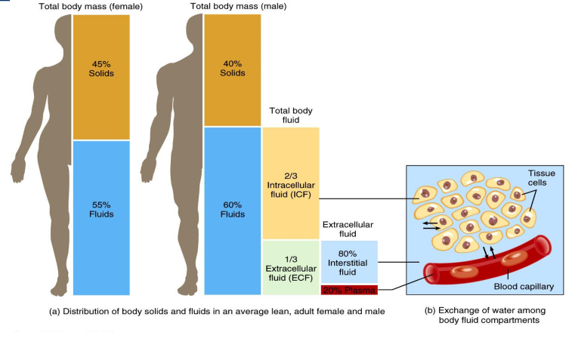
Barriers separate ICF, interstitial fluid and plasma:
1- Plasma membrane: Separates ICF from surrounding interstitial fluid.
2- Blood vessel wall: Separate interstitial fluid from plasma.
The composition of body fluids:
1- Organic substances: Glucose, Amino acids, Fatty acids, Hormones, and Enzymes.
2- Inorganic substances: Sodium, Potassium, Calcium, Magnesium, Chloride, Phosphate and Sulphate.
Difference between Intracellular fluid (ICF) and Extracellular fluid includes:
ECF | ICF
Most abundant cation - Na⁺:  - Muscle contraction  - Impulse transmission  - Fluid and electrolyte balance | Most abundant cation - K⁺ :  - Resting membrane potential  - Action potentials  - Maintains intracellular volume
Most abundant anion - Cl⁻ :  - Regulates osmotic pressure  - Forms HCl in gastric acid | - Regulation of pH.
 | - Anions are proteins and phosphates (HPO4²⁻)

Na+ /K+ pumps play a major role in keeping K+ high inside cells and Na+ high outside cell :
Na+/K+ (Sodium/Potassium) Pump :
The Na+/K+ pump is found in the membranes of many types of cells. In particular, it plays a very important role in nerve cell membranes. Notice that 3 positive ions (Na+) are pumped out of the cell (towards ECF) for every 2 positive ions (K+) pumped into the cell (towards ICF). This means that there are more positive charges leaving the cell than entering it. As a result, positive charge builds up outside the cell compared to inside the cell. The difference in charge between the outside and inside of the cell allows nerve cells to generate electrical impulses which lead to nerve impulses.
The Na+/K+ pump illustrates "active transport" since it moves Na+ and K+ against their concentration gradients. That is because there is already a high concentration of Na+ outside the cell and a high concentration of K+ inside the cell. In order to move the ions (Na+ and K+) against their gradients, energy is required. This energy is supplied by ATP (adenosine triphosphate). An ATP molecule floating inside the cell binds to the pump transferring some energy to it. As the energy is used, the ATP falls off and having lost its energy it is converted into ADP (adenosine diphosphate).
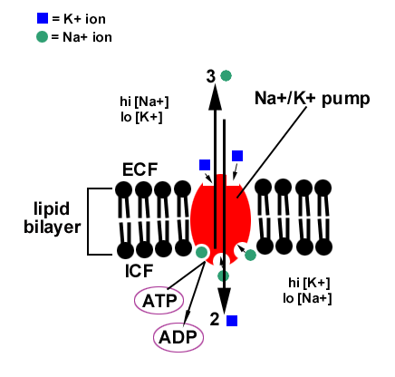
Notice in the diagram that there are 3 binding sites for the 3 Na+ ions on the inner surface of the pump and 2 binding sites for the 2 K+ ions on the outer surface of the pump. The shape of these binding sites ensures that only Na+ and K+ can bind and be transported.
Since the pump requires an ATP every time it works, ATP must be constantly supplied to the cell. ATP is created during the processes called "cellular respiration" which occur inside the cell (in the ICF).
Sodium Na⁺ :
The reference range for serum sodium is 135 to 148 mmol/L (mEq/L). Sodium has an important influence on osmotic concentration and determines the extracellular fluid volume. Water moves back and forth across cell membranes to maintain sodium balance; rapid shifts in the water volume in cells can damage or destroy cells. Sodium concentration is influenced by aldosterone levels and kidney function. Most abundant ion in ECF, 90% of extracellular cations.
Hypernatremia:
Increased concentration of sodium, occurs in dehydration, hyperadrenalism (Cushing’s disease), and diabetes
Hyponatremia:
Decreased concentration of sodium, occurs in severe diarrhea, acidosis of diabetes mellitus, decreased aldosterone secretion (Addison's disease), and renal diseases that affection excretion or secretion in the kidney tubules.
Potassium K⁺ :
The reference range for serum potassium is 3.8 to 5.5 mmol/L (mEq/L). Potassium is excreted by the kidney.
  - Most abundant cation in ICF.
  - Establish resting membrane potential in neurons and muscle fibers.
  - Maintains normal ICF fluid volume.
  - Helps regulate pH of body fluids when exchanged for H⁺.
Hyperkalemia:
Increased serum potassium, can occur when potassium leaves cells rapidly; hyperkalemia can occur in anoxia and acidosis. Increased blood potassium levels cause a decrease in muscle function.
Hypokalemia:
Decreased serum potassium, can be due to decreased intake of potassium, increased levels of aldosterone, or increased loss of potassium caused by excessive vomiting, diarrhea, or use of diuretics.
Chloride CI⁻ :
Chloride is the anion with the highest extracellular concentration; the reference range for serum chloride is 98 to 108 mmol/L (mEq/L).
  - Most prevalent anion in ECF.
  - Moves easily between ECF and ICF because most plasma membranes contain Cl leakage channels and transporters.
  - Can help balance levels of anions in different fluids.

Bicarbonate (HCO₃– ) (CO₂ Content) :
The bicarbonate anion is part of the blood buffer system that helps maintain a normal blood pH of 7.4; it is usually measured and reported as total CO₂ (carbon dioxide). The reference range for serum total CO₂ (bicarbonate) is 22 to 28 mmol/L (mEq/L). Carbon dioxide is constantly generated by metabolic processes. Combining CO₂ and water (H₂O) creates carbonic acid (H₂CO₃–), which is converted to hydrogen ion (H⁺) and bicarbonate (HCO₃–).
H₂O +CO₂ → H2CO₃→H+HCO₃
- Second most prevalent extracellular anion.
- Concentration increases in blood passing through systemic capillaries picking up carbon dioxide.
- Chloride shift helps maintain the correct balance of anions in ECF and ICF.
Magnesium Mg⁺⁺ :
The reference range for serum potassium is 0.7–1 mmol/ L.
- Mg²⁺ in ICF (45%) or ECF (1%).
- Second most common intracellular cation.
- Cofactor for certain enzymes and sodium-potassium pump.
- Essential for synaptic transmission, normal neuromuscular activity, and myocardial function.
Specialized Fluids of the Body :
Lymph, Milk, Cerebrospinal fluid, Amniotic fluid, Aqueous humor, Sweat, and Tears
Lymph :
- Clear and colorless fluid.
- 96% water and 4% solids.
- Solids :
1- Proteins :
- 2-6% of solids.
- albumin, globulin, fibrinogen, prothrombin, clotting factors, antibodies, and enzymes.
2- Lipids :
- 5 - 15% solid.
- Chylomicrons.
- Lipoproteins.
3- Carbohydrates :
- Glucose mainly.
4- NPN :
- Urea and creatinine.
5- Electrolytes :
- Sodium, calcium, potassium, chloride, and bicarbonates.

Functions of Lymph :
1- Return protein from tissue spaces into the blood.
2- Redistribution of fluid.
3- Removal of bacteria, toxins and other foreign bodies from tissues.
4- Maintain structural and functional integrity of the tissue.
5- Route for intestinal fat absorption.
6- Transport lymphocytes.
Milk :
- Secreted by mammary glands.
- Complete natural food.
- 83-87% water and 13-17% solids.
- Solids :
1- Carbohydrates: Lactose
2- Lipids :
- Triacylglycerols.
- Palmitic acid, myristic acid, stearic acid, lauric acid, butyric acid and oleic acid.
3- Proteins:
- Caesin (80%), Lactalbumin.
- Enzymes (proteases, xanthine oxidase, lysozyme), immunoglobulins.
4- Minerals :
- Ca, Mg, P, Na, K, and Cl.
5- Vitamins :
- Fat and water-soluble vitamins except for Vit - C.
Functions of Milk :
1- Milk sugar provides galactose, a structural unit for growing infant.
2- In the intestine, it gets metabolized to lactic acid which eliminates harmful bacteria.
3- Source of protein, mineral, and vitamins.
Cerebrospinal fluid (CSF) :
- Clear, colorless liquid formed within the cavities of the brain and around the spinal cord.
- At any given time, there is 120-150ml CSF in the system.
- CSF is completely replaced about three times a day.

Functions of CSF :
1- Hydrolic shock absorber.
2- Regulation of intracranial pressure.
3- Influences the hunger sensation and eating behaviors.
Amniotic Fluid :
- The liquid produced by membranes and fetus.
- The volume of fluid increases with gestational age.
Functions of AF :
1- Physical protection to the fetus.
2- Medium for the exchange of various chemical.
Aqueous Humor :
- The fluid that fills the interior chamber of the eye.
- Secreted by the ciliary body, enters anterior chamber.
- Blockade in the flow of aqueous humor causes glaucoma due to increased intraocular pressure.
- Posterior chamber of the eye is filled with vitreous humor which contains a gel (vitreous body of hyaluronic acid secreted by retina).
Sweat :
- Secretion of sweat gland.
- Regulates body temperature by cooling and evaporation.
- Sweat glands controlled by ANS, Adrenal cortical steroid - which affect the quantity of electrolyte present.
- Insensible perspiration amounts to 800-1200ml/day.
- The volume of sweat produced/day during muscular exercise at elevated temperature may range from 10-14l, which may lead to water and electrolyte imbalance.
- A water content of sweat varies from 99.2-99.7%.
- pH – 4.7 to 7.5.
- Total non-protein nitrogen (urea) varies from 0.071% per hour during copious sweating.
- The electrolyte in sweat varies:
Na+ 12.6-127 meq/l.
K+ 5-32 meq/l.
Cl- 8.5-85 meq/l.

Tears :
- Produced by lachrymal glands.
- Isotonic but becomes hypertonic due to evaporation as the fluid passes over the cornea.
- When the tear flow is copious, fluid is isotonic.
- Under stimulus with a slow rate of tear flow, the fluid is about 25m osm hypertonic Copius – Rapid tear flow induction.
- pH – 7 to 7.6 due to loss of CO2.
- Protein content is 0.6 to 0.18g/dl with an albumin/globulin ratio of 1:5 or 2:1.
- A small amount of mucin is also present.
- Lysozyme – lyses the cells of a number of micro-organisms by breaking down. the polysaccharides of their outer layer.
Functions of Tears :
1- Lysozyme protects the eye from infectious agents.
2- Lubricate the surface of the cornea.
3- Fill the irregularities of the corneal surface to improve optical properties.
4- Protects eyes from injury.

