Dental chemistry College of dentistry
First year Lec. 4

Acid base balance
The chemical reactivity of water in biological systems is due to its ability to ionize:

Dissociation constant of water can be expressed in terms (K):

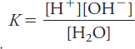
The ionization constant of water (Kw):

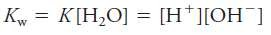
In pure water [H+]=[OH-]
Kw = 10⁻¹⁴

To describe such solutions, the [H⁺] is expressed as a pH:

A pK value describes an acid’s the tendency to ionize. Most biologically acids and bases do not dissociate completely when added to water.

For example, acetic acid partially ionizes, or donates only some of its protons to water:
The equilibrium constant (K) expressed by:
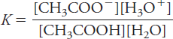
Because of H₂O the concentration is much higher than the other concentrations, it is considered constant than Ka, the acid dissociation constant:
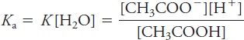

Exercise:
For acetic acid, the acid dissociation constant is 1.74×10⁻⁵, calculate pK?
Answer:
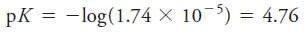

Henderson–Hasselbalch equation.
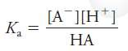
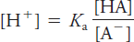
It relates the pH of a solution to the pK of an acid. It can be derived as follow:

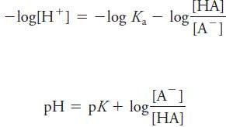

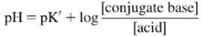

Buffer system
Buffer resists change in pH solutions when acids or bases are added. They are a mixture of a weak acid (HA) and its conjugate base (A⁻) or a mixture of a waek base (B) and its conjugate acid (HB⁺).

There are three buffer systems in the body: 1- Bicarbonate buffer.
- Phosphate buffer.
- Protein buffer.
Bicarbonate buffer system:
Henderson-Hasselbalch equation is used to relate the pH to bicarbonate buffer system of the blood as follow:
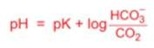
pK for bicarbonate buffer is 6.1
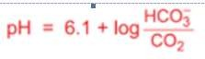

Bicarbonate buffer is present in extracellular fluid (ECF) in plasma. It consists of the protonated substance carbonic acid (H₂CO₃) which is a weak acid and the unprotonated substance
3
3

HCO
- which is a weak base. HCO
- is in the form of salt

sodium bicarbonate (NaHCO₃). The reaction at equilibrium is:
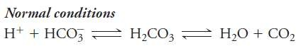

Due to Le Chatelier's principle:
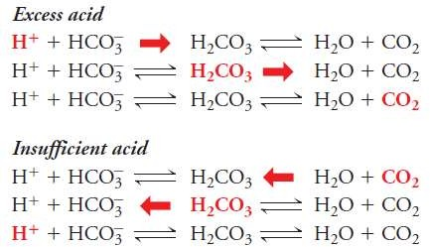

When strong acid such as HCl is added, the pH decreases quickly because of the strong HCl acid dissociates into H⁺ and Cl⁻, but when this acid react with buffer system as follows:
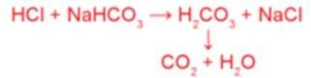
This reaction prevents pH to decrease.

Bicarbonate buffer system also prevents the increase in pH in a fluid to which a strong base such as NaOH is added. In this case, the addition of H₂CO₃ prevents pH to increase.
Phosphate buffer system is useful in the intracellular fluid (ICF). In phosphate buffer, it consists of dihydrogen phosphate (H₂PO₄⁻) as weak acid which dissociate to H⁺ and hydrogen phosphate as weak base (HPO₄⁻²) and both ions exist as sodium salts
When strong acid added (HCl):
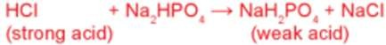
When strong base added (NaOH):
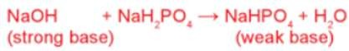

Protein buffer system:
The acidic and basic protein side chains accept or donate H⁺ to limit change in pH and albumin is the important one of this type.

Buffer systems of blood and exchange of O₂ and CO₂
H⁺ is the smallest ion and it combines with many negatively charged and such changes of H⁺ affect the functions of enzymes, cell membranes and nucleic acid and dramatically alter their physiological activity. The normal physiological pH of blood ranges from 7.35- 7.45 (average 7.4). If the plasma pH reaches either 6.8 or 7.8, death may be unavoidable. Buffer systems maintain a fairly constant pH in body fluids.
The major metabolic product from oxidation of ingested carbon compounds is CO₂. Hydration of CO₂ dissolved in water yields the weak acid H₂CO₃ (carbonic acid).

The normal balance between rates of elimination and production of CO₂ yields a steady state concentration of CO₂ in the body fluids and a relatively constant pH.
The ratio of HCO₃⁻ to H₂CO₃ at a physiological pH of 7.4 can be calculated by means of employing the Henderson-Helbalch equation:
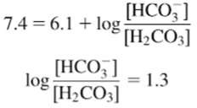
Taking antilogarithms:
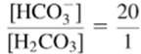
The carbonic acid term can be replaced by a pressure term because the carbonic acid concentration is proportional to P_{CO2}.
[CO₂] = P_{CO2} (mmHg) × 0.03
0.03 = (the solubility factor in mmol/L/mmHg at 37º C in plasma).

In normal arterial blood: P_{CO2} = 40 mm Hg
[HCO₃⁻] = 24 mmol/L

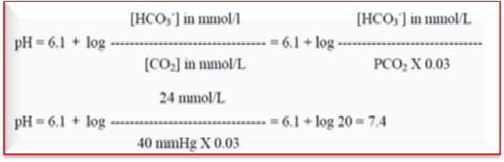

Note that there is:
- A direct relationship between pH and bicarbonate concentration.
- An inverse relationship between pH and bicarbonate concentration

Alteration in body acid base balance is reflected in blood, so, these clinical disorders are defined according to the pH deviations observed in plasma. Acidemia occurs when the blood pH is lower than 7.35. Conditions causing academia are designated with term acidosis. Alkalemia consists in the increase in blood pH above 7.45 and is produced by conditions that lead to alkalosis.
Buffer disorders of acid-base balance can be distinguished into four main groups:
A-Respiratory acidosis B-Metabolic acidosis C-Respiratory alkalosis D-Metabolic alkalosis

Respiratory acidosis:
Reduction of CO₂ removal by the lung results in increase of the partial pressure of CO₂ (P_{CO2}), this results in a raise of carbonic acid concentration and a decrease in blood pH. Without adjustment by the body, this condition is called noncompensated acidosis.
This situation is produced by diseases where pulmonary ventilation is compromised, which reduces gas exchange, for example:

A-Hypoventilation by depression of the respiratory center (by drugs or other agents).
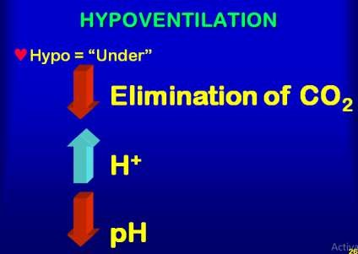
B- Respiratory failure due to plumonary diseases that disturb ventilation).
C- Circulatory deficiencies that decrease blood flow to the lung and slow lung gas exchange.
To compensate for the imbalance, the kidneys will increase bicarbonate reabsorption and increase the urinary secretion of acid (H⁺) and ammonia. These effects increase bicarbonate concentration in plasma, tending to restore the value of [HCO₃⁻]/ [CO₂] ratio to normal levels (20/1 and a pH =7.4). This situation is known as compensated acidosis.

Metabolic acidosis
This condition causes a primary reduction in plasma bicarbonate and it is produced by excessive loss of bicarbonate or the increased production, retention, or intake of acids. The reduction of [HCO₃⁻] results in reduced blood pH (noncompensated acidosis). This type of disturbance occurs in uncontrolled diabetes, starvation and other situations in which

there is loss of digestive juices rich in bicarbonate, or in kidney failure in which tubular H⁺ secretion mechanisms are disturbed.
The intermediate compensatory response in this type of alterations is the stimulation of the respiratory center to increase pulmonary ventilation, which tends to decrease P_{CO2} and [CO₂].
If renal function is normal, the kidneys will respond with increased excertion of acid and production of ammonia (which increases urine acidity and net acid excretion). This restoration of body pH is known as compensated acidosis.

Respiratory alkalosis
This is a condition in which the primary alteration is the decrease in P_{CO2}. This occurs during pulmonary hyperventilation due to:
  - abnormal stimulation of the respiratory center by diseases, such as encephalitis.
  - Pronounced hypoxia.
  - Salicylate intoxication.
  - Patients with anxiety and hysteria.
The decrease in {H₂CO₃] produces a raise in pH (uncompensated alkalosis). Compensation includes increased bicarbonate secretion by the kidneys and lower net acid excretion

Hyperventilation is a condition in which you start to breathe very fast

Metabolic alkalosis.
This state is produced by a primary increase in bicarbonate, which elevates blood pH (uncompensated alkalosis). It can result from excessive intake of alkali (NaHCO₃) or by excessive removal of acids from the body. The most common example for this condition is

continuous vomiting, caused by many different pathologies in which gastric juice, rich in hydrochloric acid is lost.
Compensatory mechanisms for this condition include:
- depression of ventilation, which decreases CO₂ elimination
- The reduction of bicarbonate reabsorption and ammonia formation (net acid excretion decrease) by the kindneys.
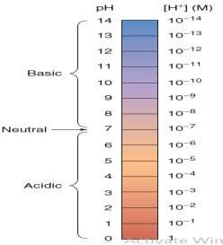
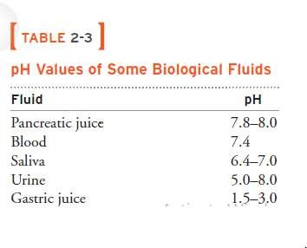

Conversion of [H⁺] to pH`:
Example: calculate the pH of a solution with [H⁺] =40 nmol/L Answer:
pH= - log [H⁺]
pH= – log [40x10⁻⁹]
(nano mol= 10⁻⁹ mol): (pH=-log[H⁺])= -log 40×10⁻⁹
= 9 –log40
= 9 – 1.6

= 7.4
Normal values
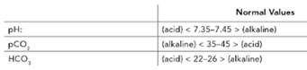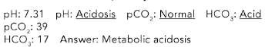

……………………..
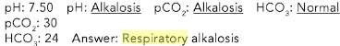
………………………..
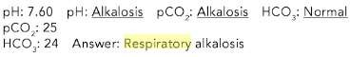

pH and dental carries
Sucrose can be easily and rapidly metabolized by the plaque flora. Sucrose fermentation produce lactic acid causing pH drop to less than five at the region of interface between enamel and plaque.
During meals, when sucrose is ingested, sufficient saliva is released to regulate the buffer and maintain the plaque pH, so decay does not occur. When the same amounts of sucrose were ingested between meals, new decay will observed.
Acid producing bacteria, like Streptococcus mutans (type of bacteria) existed in normal oral flora in significant levels, these bacteria metabolize fermentable carbohydrates in food and produce several organic acids, causing demineralization of enamel due to reduction of pH in dental plaque and it is seen more active at pH 5 and less, at which the teeth begin to demineralize (mineral is solubilized) and a cavitation occurs in the enamel then it will be extends into the dentin in which the growth of lactobacilli is favored and they are considered the most active bacteria which produce acid. The acid will corrode the minerals of enamel below the plaque caused decalcification of enamel followed by cavitation and brownish discoloration. In the later stage, the acid removes dentin to expose the pulp, lead to inflammation and toothache.

Stephan curve
Frequent ingestion of sucrose has large influence in initiation and development of dental caries process. Stephan determined the relation between pH dropping and dental caries. His experiments are based on recording the pH of dental plaques in situ 1- before, 2- during and 3- after rinsing of the mouth with a 10% glucose or sucrose solution. A typical pH of plaque after exposure to a glucose rinse is obtained. This curve is referred to as Stephan curve.
Under resting conditions, pH of plaque is constant (about 6.9-7.2). He recorded that pH drops very rapidly (in few minutes) after exposure to sugars to the lowest level of 5.5 to 5.2 which called (critical pH) and then the teeth is at risk. During this period, the tooth mineral dissolves at lower pH results to mineral loss (demineralization). Later slowly, pH returns to its original value over a period of 60 minutes. Repeated fall of pH leads to more and more mineral loss resulting in intitiation of dental caries.
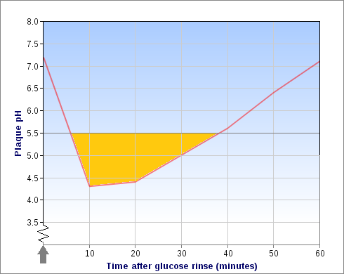

Stephan curve

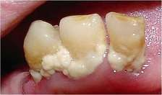
dental plaque

In resting saliva, bicarbonate concentration is as low as 3 mmole/liter, but it increases with flow rate and reaches about 30 mmole/liter in stimulated saliva. So during intake, two important events happen:
- Bacteria ferment carbohydrates and produce organic acid, causing a drop in pH.
- The increased salivary flow rate leads to an increased bicarbonates concentrations) remember that there is direct relationship between pH and bicarbonate concentration), so increased salivary icrease pH and deacrease acidity

Saliva buffer capacity and pH regulation
After intake of sugar containing foodstuffs the pH in plaque will drop and remain lowered until the sugar is cleared from the mouth and the bacterial produced acid is buffered. The magnitude of the pH drop is determined by the amount of acid that is produced by bacteria and by the saliva buffer capacity, the latter working at counteracting the pH drop. As tooth demineralization can occur when the actual pH drops below the
critical pH, it is crucial to reduce the time that the actual pH stays below this value.
Several terms have been used for determination of saliva buffering capacity. One is the amount of acid that is needed to lower the pH from the original saliva pH value to a predetermined lower value. This term could be donated the titratable base. Test systems that use this method are available in various chairside for the dental clinic.
If the addition of large amounts of acid results in only a minor pH change the buffer capacity is high and vice versa.

References:
  - Charlotte P., Kathleen C., Essential Biochemistry, 3rd ed., WILEY, 2014.
  - Jeannette N., medical sciences, 2nd edit, saunders, Elsevier, 2015
  - john H. Byme, Leonard R. Johnson, Essential medical physiology 3rd edit., academic press, Elsevier, USA, 2003.
  - Deborah C. Wirwicz,, Mary A. Miller., Teach Med-Surg Nursing, USA, 2015.
  - Lakshman S., Essential Microbiology for Dentistry E-Book, Elsevier, 2012.
  - Zhou X., Dental Caries: Principles and Management, Springer, 2015.
  - Ole Fejerskov, Edwina Kidd, Dental Caries: The Disease and Its Clinical Management, 2nd ed., WILEY,2008

